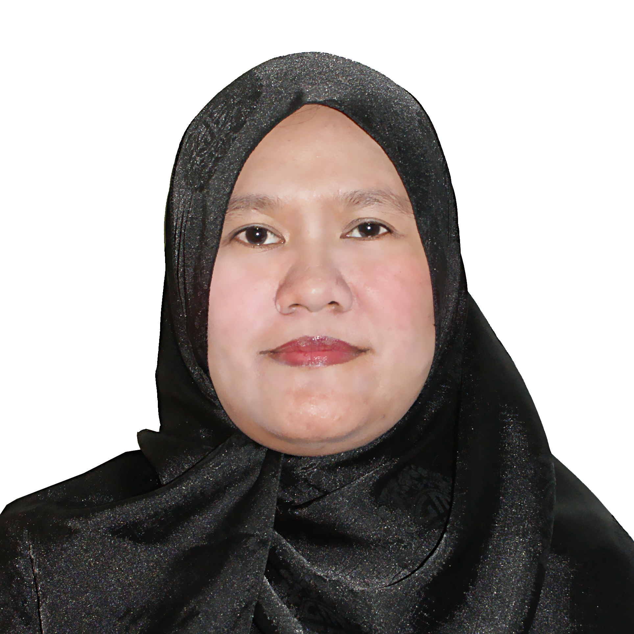
MARIETTA B. MANALO, RN
91 Sitio Mani, Iba Meycauayan, Bulacan, Philippines
maryet_manalo@yahoo.com
+639284460910

Objective: To be able to work in a hospital where I can practice as a Staff Nurse in which I can give quality Nursing care to all patients regardless of creed, color, nationality or religion.

Educational Attainment
St. Rita Hospital College of Nursing and School of Midwifery
Bachelor of Science in Nursing
Batch 1994

E. Rodriguez Jr. High School
High school graduate
Batch 1998

Ramon Magsaysay Elementary School
Elementary Graduate
Batch 1988

Professional License
Professional Regulation Commission
Board of Nursing
General average of 79.20%

Saudi Council Examination for Nurses
Passed

Work Experience
Al Mouwasat Dispensary Hofuf, KSA
Obstetrics and Gynecology Clinic
29 December, 2006 up to 15 February, 2010
Job Description:
- To establish rapport with the patient and with her family as well.
- To take vital signs correctly and accurately.
- Be able to practice patients’ right especially the privacy of female patients.
- Assisting the Physician in inserting and/or IUD with strict sterile technique.
- Providing patients’ prenatal, antenatal and postnatal needs.
- Recording of patients’ data correctly.
- Rendering nursing care to all patients in need of medical services.
- Reporting to immediate supervisor any defects in the machine.
- Assisting the patient in ultrasound room.
- Maintaining confidentiality of all patients ‘ records and datas.

Al Mouwasat Dispensary Hofuf, KSA
Emergency Room Department
20 November, 2003 up to 28 December, 2006
Job Description:
- Building good and harmonious working relationship with co-workers.
- Establishing rapport with the patients and his/her family.
- Taking of vital signs correctly and accurately.
- To monitor patients condition and to report immediately to attending physician any abnormality in his/her present condition.
- Giving of medicine using the 5 right in administering medication.
- To perform ECG correctly.
- To record all patient data correctly.
- To report to immediate supervisor any defects in medical equipments and lose in the area.
- Endorsing to co-staff the continuation of health needs and plans of the patients.
- Inserting IV cannula to patient safely.
- Rendering quality Nursing care to all patients
- To perform effective life support to patient in life threatening situation.
- Updating oneself to latest medical trends.

MCU-FDTMF Hospital, EDSA Caloocan, Philippines
Medical Intensive Care Unit
18 August 2003 up to 30 October, 2003
Job Description:
- Taking vital signs correctly and accurately.
- Maintaining the privacy of the patient.
- Giving of medicine using the 5 rights in administering medications.
- Monitor all patients’ situation and to report to Physician any untoward findings.
- Be able to relate all laboratory results to attending physician correctly and accurately.
- Maintaining harmonious relationship with co-nurses and all hospital staff.

MCU-FDTMF Hospital EDSA Caloocan, Philippines
Obstetrics and Gynecology Ward
23 April,2001 up to17 August, 2003
Job Description:
- Establishing rapport with the patient and her family.
- Excercising patients’ rights.
- Providing preoperative care to patients for caesarian section, TAHBSO, explore lap, dilatation and curettage and all gynecological procedures.
- Monitoring patients during postoperative phase.
- Giving health teachings to patients.
- Administering medication using the 5 patient rights.

Personal Information:
Birthdate: 12 December, 1971
Civil Status: Married
Name of spouse: Leonides Manalo
Name of Children: Gerard B. Manalo 12 years old
Edward B. MAnalo 10 years old

References: Held upon request.

I hereby certify that the above information are true to the best of my knowledge.

Marrietta B. Manalo

